**Challenge 08 - Bootstrap**

For this challenge, you will have to make **five fully responsive pages** using bootstrap. Refer to the *screenshots & video* folders to see the exact look of the page.

* The **navbar** (active link) has a border on the left when you are on the specified page. Also, clicking on the logo text goes back to the homepage.
* The **Homepage** slider has modified indicators and the shadow of the arrow is gone. Clicking on the play icon above “See What We Do”, opens a modal with a video in it. After that, there is a gallery where you can open every image in its full size in a modal by clicking on it.



* On the **About page**, the circled image has to be in the given position, that is not a mistake. On this page also, above the footer, there is a slider only with text, which doesn’t have indicators, only arrows.

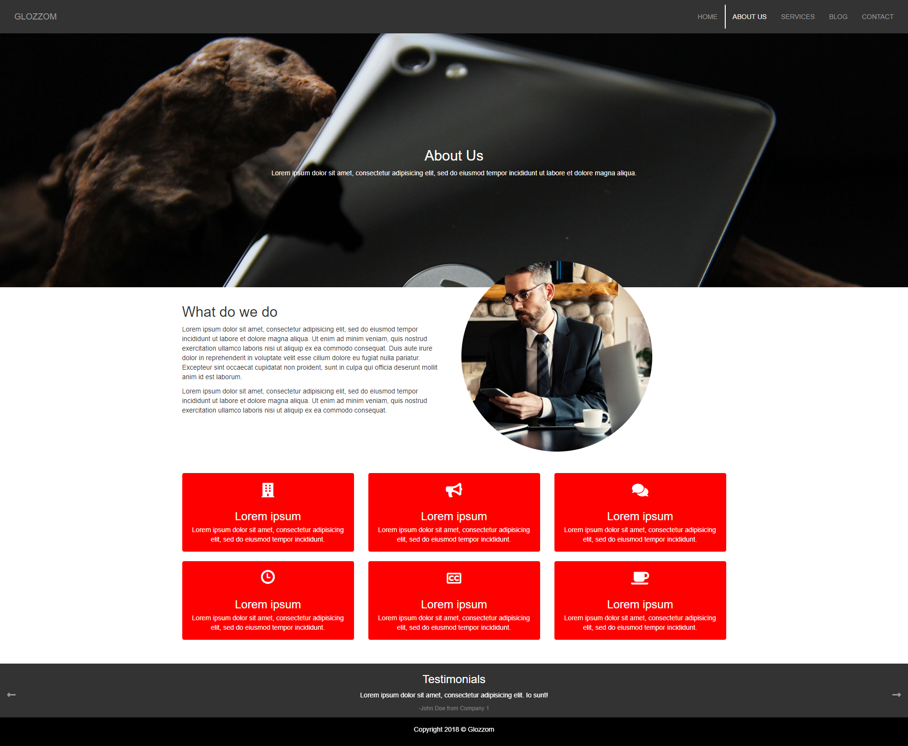

* On the **Services page**, the first banner above is not a slider. After that, three panels are displaying information about the services provided. And after them, some panels fold and are **not an accordion**, which means you can have as many of them as you want.

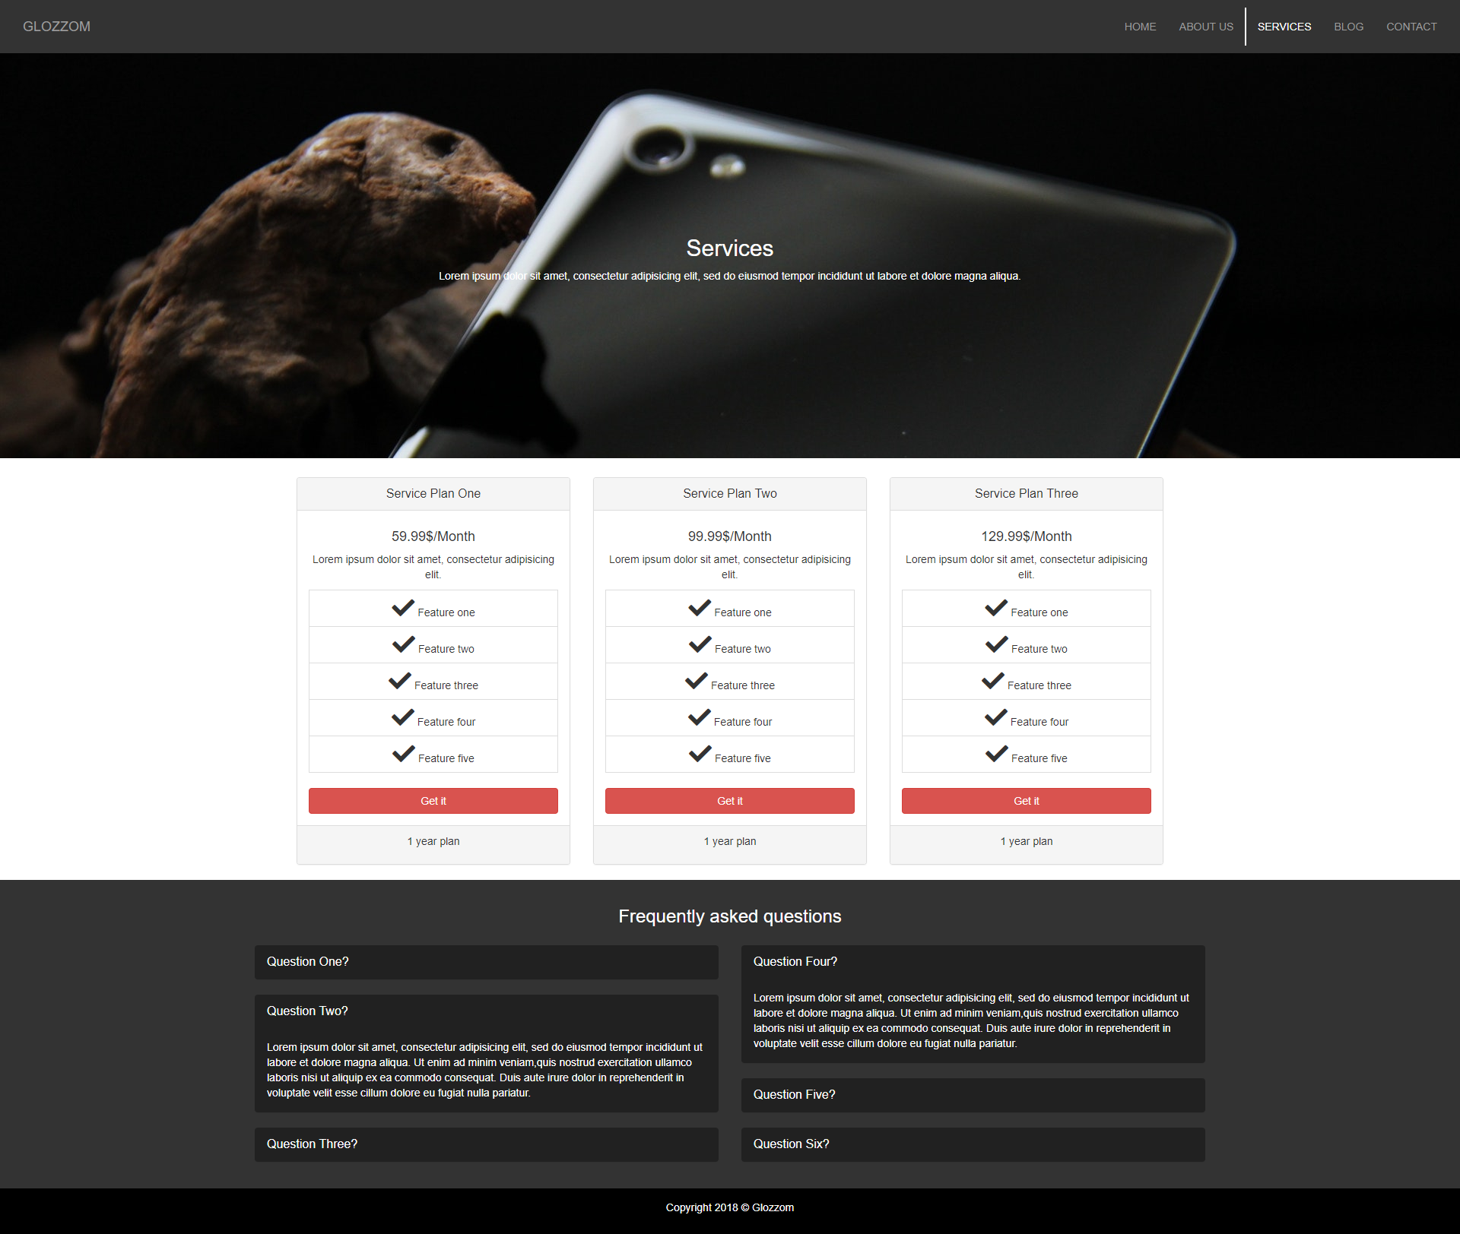

* On the **Blog page**, they are three posts, with images and content below them.
* 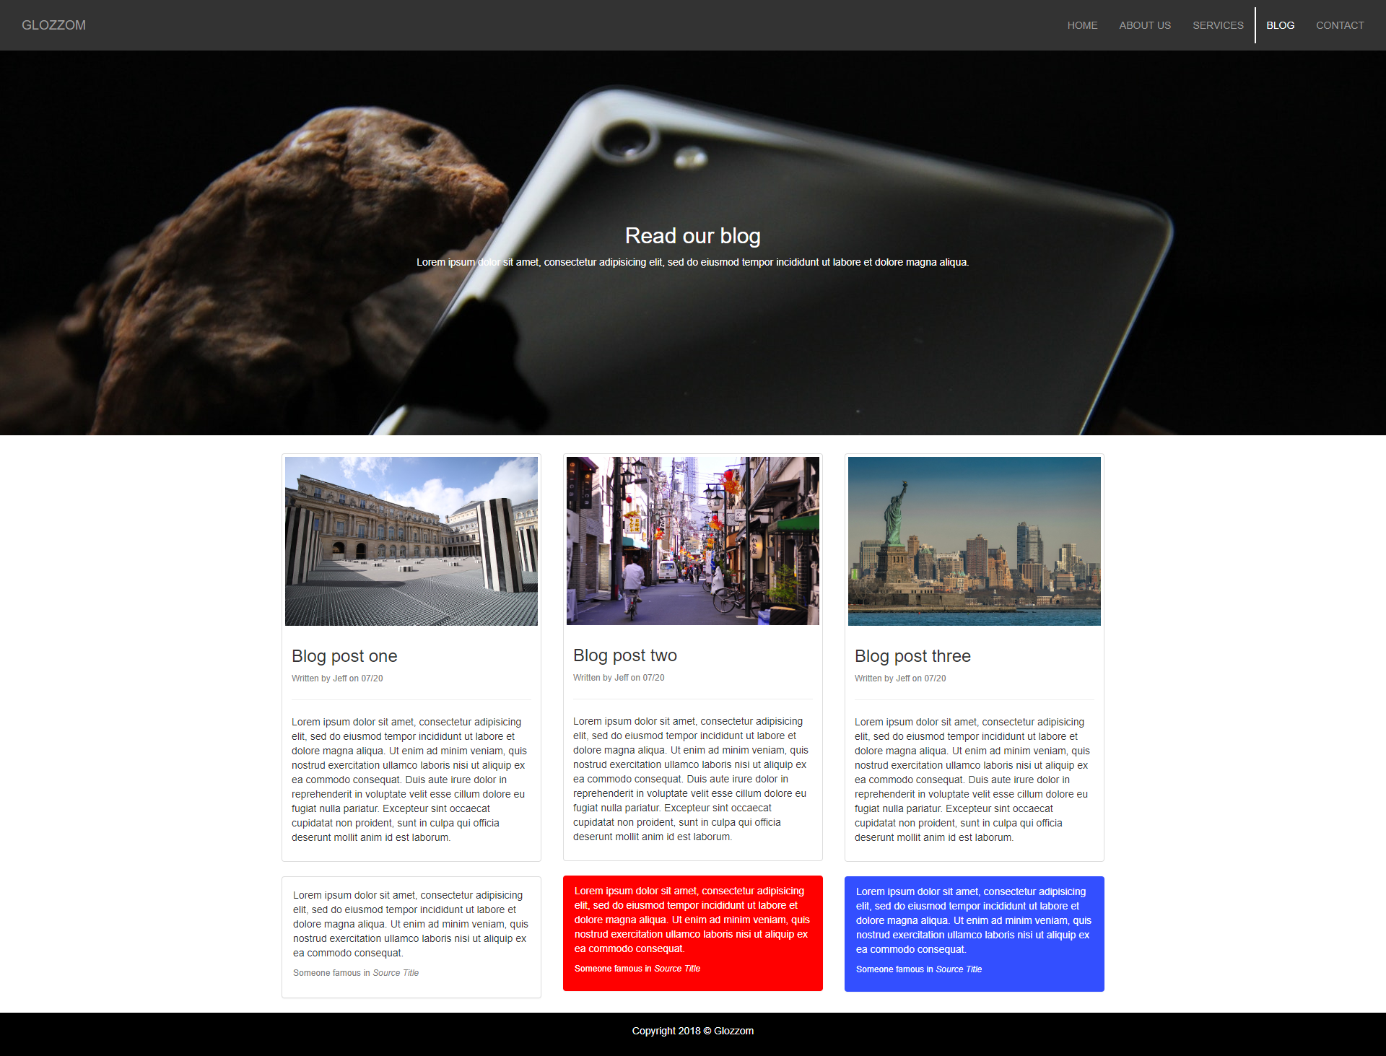
* The***Contact page*** is straight forward, so there is not anything special about it, except you will **have** to make it.

#### 

**Responsive notes:**

- The hamburger icon on the menu **must** work, but only from mobile devices.

- The homepage slider text disappears on mobile devices.

- Use only 1 css file for every page.

#### 

#### Evaluation system:

**1 point** - Whole five page’s completed in HTML & CSS.

**3 points** - All of the above + responsive for tablet & mobile.

**5 points** - All of the above + make the gallery open every picture in a modal, make the pop-up with the video, every paralax effect on the pictures, all the hover effects and the rest functionalities shown in the video.

#### Deadline:

**2 week after its presentation, 23:59h end of the day.**

#### 

#### Note:

* Bootstrap is a **must** for this challenge.